5. API Documentation

This section describes the API endpoints implemented in the Intelligent Talent Matching Platform, which supports user authentication, profile management, job search, recommendations, job applications and membership management. The APIs enable communication between the frontend interface, backend services and database components.

5.1 Authentication APIs

Endpoint | Method | Description
/api/register | POST | Register a new user account
/api/login | POST | Authenticate a user
/api/logout | POST | Logout current user
/api/me | GET | Retrieve current user information

5.2 Profile APIs

Endpoint | Method | Description
/api/profile | GET | Retrieve user profile
/api/profile | PUT | Update user profile

5.3 Job APIs

Endpoint | Method | Description
/api/jobs | GET | Retrieve all available jobs
/api/jobs/{id} | GET | Retrieve job details
/api/jobs | POST | Create a new job posting
/api/jobs/{id} | PUT | Update an existing job posting
/api/jobs/{id} | DELETE | Delete a job posting
/api/employer/jobs | GET | Retrieve jobs created by employer

5.4 Application APIs

Endpoint | Method | Description
/api/jobs/{id}/apply | POST | Submit a job application
/api/applications/candidate | GET | Retrieve candidate applications
/api/applications/employer | GET | Retrieve employer applicant list

5.5 Recommendation APIs

Endpoint | Method | Description
/api/recommendations/jobs | GET | Retrieve recommended jobs
/api/recommendations/candidates | GET | Retrieve recommended candidates
/api/jobs/{id}/recommendations | GET | Retrieve job recommendations

5.6 Membership APIs

Endpoint | Method | Description
/api/membership/upgrade | POST | Upgrade membership
/api/membership/toggle | POST | Enable or disable membership

5.7 Search APIs

Endpoint | Method | Description
/api/search/jobs | GET | Search jobs using keywords and filters
/api/search/candidates | GET | Search candidates using keywords and filters

5.8 Example API Requests and Responses

Login API
Endpoint: POST /api/login

Request Parameters :

Parameter | Type | Required | Description
email | String | Yes | User email address
password | String | Yes | User password
role | String | Yes | User role, either candidate or employer

Example Request:
{"email":"candidate@example.com","password":"password123","role":"candidate"}
Response Format:
{
"status": "success",
"user_id": 1,
"role": "candidate"
}

Job Search API
Endpoint: GET /api/search
Request Parameters :

Parameter | Type | Required | Description
q | String | No | Search keyword
location | String | No | Job location
work_mode | String | No | Remote/Hybrid/On-site
skill | String | No | Required skill

Example Request:
GET /api/search?q=software&location=Sydney&work_mode=Remote&skill=Python
Response Format:
{
"results": [
{
"id": 1,
"title": "Software Engineer"
}
],
"count": 1
}

Create Job API
Endpoint: POST /api/jobs
Request Parameters :

Parameter | Type | Required | Description
title | String | Yes | Job title
location | String | Yes | Job location
salary | String | Yes | Salary range
required_skills | String | Yes | Required skills

Example Request:
{"title":"Software Engineer","location":"Sydney","salary":"$90k-$110k","required_skills":"Python, SQL"}
Response Format:
{"status":"success"}

Apply Job API
Endpoint: POST /api/jobs/{id}/apply
Request Parameters :

Parameter | Type | Required | Description
job_id | Integer | Yes | Job identifier

Example Request:
POST /api/jobs/1/apply
Response Format:
{"status":"success","message":"Application submitted"}

6. Testing

6.1 Testing Strategy
To validate the complete workflow of the Intelligent Talent Matching Platform, integration testing was applied to verify interactions between frontend pages, backend APIs and database components. Testing was performed using Flask test clients and automated backend test scripts.

6.2 Testing Environment
Backend testing was run using Python and Flask. The test script simulated real candidate and employer interactions with the system. The testing environment included frontend pages, backend APIs and SQLite database components.

6.3 Test Cases

Test Category | Description | Result
Authentication Testing | User registration, login, logout and token verification | PASS
Profile Management Testing | Candidate and employer profile creation and editing | PASS
Search Function Testing | Keyword search, filtering, fuzzy search and role-based search | PASS
Recommendation Testing | Candidate and employer recommendation generation | PASS
Membership Testing | Membership upgrade, toggle and access control | PASS
Job Management Testing | Job creation, editing, listing and deletion | PASS
Application Testing | Job application submission and duplicate application prevention | PASS
Security and Authorization Testing | Protected endpoint authorization and role validation | PASS
Frontend Integration Testing | Registration and login page redirection validation | PASS

6.4 Testing Results
A total of 23 automated integration test cases were executed using the backend test script. The tests covered authentication, profile management, job search, recommendation generation, membership management, job posting, application handling and authorization control. All 23 test cases passed successfully. No critical errors were identified during testing. The results indicate that the Intelligent Talent Matching Platform operates correctly for both candidate and employer workflows.

6.5 Test Evidence
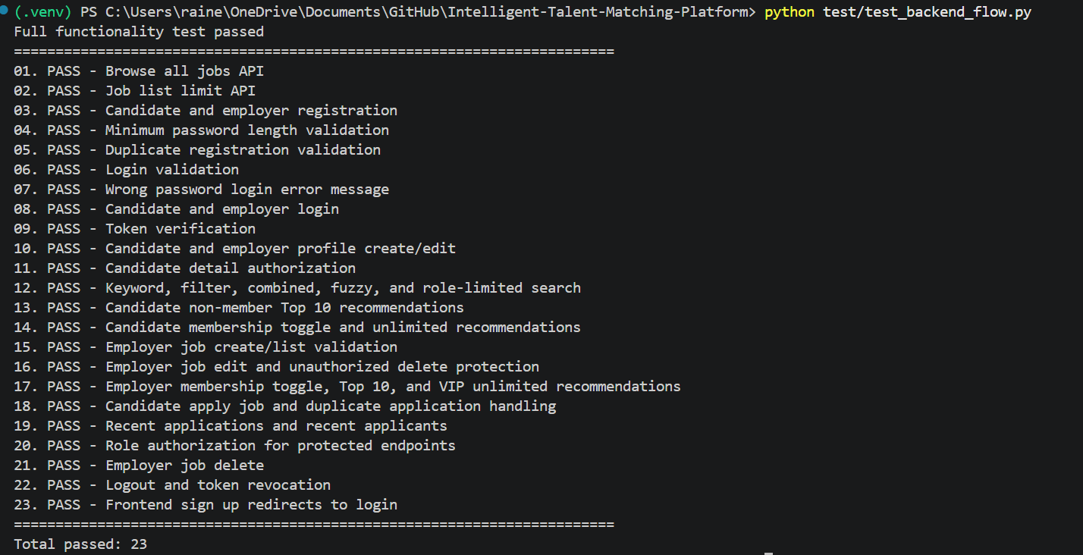 Figure 1. Automated Backend Integration Testing Results

